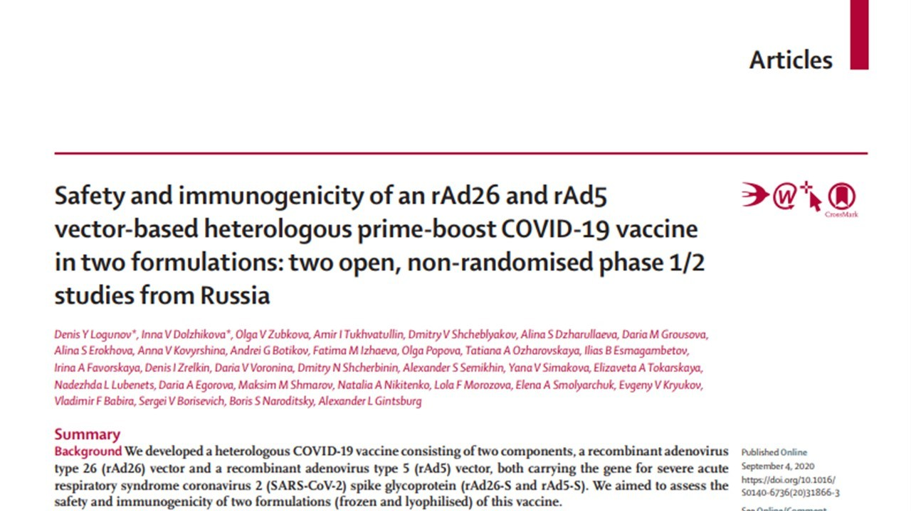
Open letter to DY Logunov et al., authors of:
“Safety and immunogenicity of an rAd26 and rAd5 vector-based heterologous prime-boost COVID-19 vaccine in two formulations: two open, non-randomised phase 1/2 studies from Russia.” Lancet. 2020;0(0). doi:10.1016/S0140-6736(20)31866-3
Available at:
https://www.thelancet.com/journals/lancet/article/PIIS0140-6736(20)31866-3/fulltext
and to Richard Horton (editor of The Lancet).
OBJECT.
The study reports the results of a phase 1/2 study on an adenovirus-based vaccine, using Ad5 and Ad26 vectors for the spike protein of SARS-CoV-2 as antigen, and two different formulations (liquid and lyophilized).
During the current pandemic, the extreme public interest and expectations for an effective vaccine are understandable. However, the very same reasons should motivate the scientific community to pay even more attention to the scientific evidence and the underlying data, and it is thus of utmost importance that they are fully available for close scrutiny. Numerical data for all the experiments and original FACS files in fcs format, for example, would be of great help in evaluating the present study, enabling direct reproduction of all analyses and findings, rather than trying to do so from data abstracted or inferred from the figures.
While the research described in this study is potentially significant, the presentation of the data raises several concerns which require access to the original data to fully investigate. These are detailed below.
POTENTIAL DATA INCONSISTENCIES IN FIGURES 2, 3 AND 4.
In figure 2, the authors report the reciprocal titre of RBD IgG and neutralizing antibodies at different time points, for all the patient groups (challenged with different formulations).
As evident by the following reproduction, there are several data patterns which appear repeatedly for the reported experiments. To this end, connecting measurements for each individual across time points would be highly beneficial in reporting (and hence) interpreting the results. This suggestion also applies to similar measurements in the other manuscript figures.
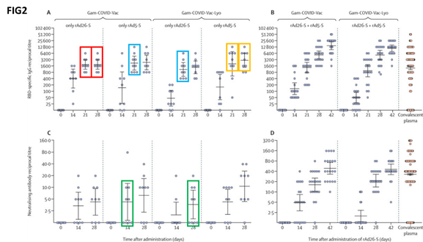
In the red boxes, 9 out of 9 volunteers challenged with rAd26-S appear to have identical antibody titres at 21 and 28 days; this is also true for 7 out of 9 volunteers challenged with rAd5-S (yellow boxes). Furthermore, in the cyan boxes we can see all the experimental points differing for a constant value in two completely unrelated experiments; and 8 out of 9 experimental points are completely preserved among other two completely unrelated volunteer groups (green boxes).
While we understand that in this case the variable under study is discrete (representing the reciprocal of a dilution), still it seems to us that on the ground of simple probabilistic evaluations the fact of observing so many data points preserved among different experiments is highly unlikely.
For figure 3, intended to present the results of the cellular response to the different formulations used for challenging the volunteers, in the following reproduction repeated experimental point patterns are boxed with the same colours as in the previous case, with an important difference: in this case, the variable under study (cell proliferation %) is continuous in nature, rendering the coincidence of data points among different experiments even less likely.
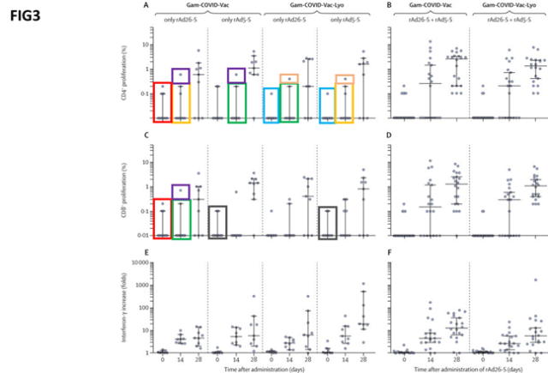
For figure 4, which is intended to show the neutralizing antibody formation against the adenovirus vectors used for the vaccine, problems like those observed for figure 2 are again apparent. The coloured boxes in the following reproduction are to be intended as in the previous cases.
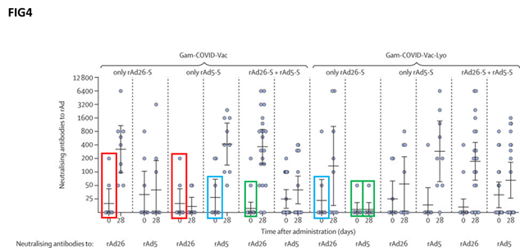
Please note that, in lack of the original numerical data, no conclusions can be definitively drawn on the reliability of the data presented, especially regarding the apparent duplications detected.
FURTHER CONCERNS.
The authors did not specify enough characteristics of the convalescent patients used as a control for the evaluation of the humoral response in figure 2. How were they matched to the different groups of enrolled volunteers? Since there are several convalescent control patients which apparently are seronegative and are also negative for neutralizing antibodies, it is also crucial to know when their plasma was collected – for each patient, how many days passed since symptoms and seronegativization occurred? How many convalescent controls were used for the graphs in figure 2?
SIGNATURES.
Dr. Konstantin Andreev – Northwestern University (USA)
Dr. Yves Auberson – President, European Federation for Medicinal Chemistry (Switzerland)
Prof. Maurizio Battino – Università Politecnica delle Marche (Italy)
Dr. Joseph Bertolini – Retired (Australia)
Prof. Anders Björkman – Karolinska Institutet (Sweden)
Prof. Enrico Bucci – Temple University (USA)
Prof. Raffaele Calogero – Turin University (Italy)
Prof. Ernesto Carafoli – VIMM (Italy)
Dr. Piero Carninci – RIKEN Center for Integrative Medical Sciences (Japan)
Prof. Paola Castagnoli – Director, Toscana Life Sciences (Italy)
Eng. Silvano Coletti, Chelonia SA (Switzerland)
Prof. Pellegrino Conte – Palermo University (Italy)
Prof. Andrea Cossarizza – University of Modena and Reggio Emilia (Italy)
Prof. Paolo Costantino – Rome University “La Sapienza” (Italy)
Dr. Massimo Degano – IRCCS Ospedale San Raffaele (Italy)
Prof. Michele De Luca – University of Modena and Reggio Emilia (Italy)
Dr. Andrea Grignolio – CNR (Italy)
Dr. Matthias Goerlach – Leibniz Institute on Aging-Fritz Lipmann Institute (Germany)
Prof. Philippe Guerin – Director, Infectious Diseases Data Observatory and Centre for Tropical Medicine and Global Health – Oxford University (UK)
Prof. Samir Kabbabe – Hospital Universitario de Caracas (Venezuela)
Prof. Riccardo Leardi – Genoa University (Italy)
Prof. Brian Lipworth – Dundee University (UK)
Prof. Luigi Marchionni – Weill-Cornell Medicine (USA)
Prof. Valentina Massa – Milan University (Italy)
Prof. Cristina Mussini – University of Modena and Reggio Emilia (Italy)
Prof. Angelo Parini – INSERM (France)
Prof. Gianluca Sbardella – Salerno University (Italy)
Prof. Stephen M. Smith – University of Toronto (Canada)
Dr. Domenico Somma – Glasgow University (UK)
Dr. Teresa Stocki – Leeds Teaching Hospitals NHS Trust (UK)
Prof. Donald Thea – Boston University (USA)
Prof. Loretta Tuosto – Rome University “La Sapienza” (Italy)
Dr. Christoffer van Tulleken – University College London (UK)
Dr Mirella Vivoli Vega – Exeter University (UK)
Prof. Antonella Viola – Università degli studi di Padova (Italy)
Dr. James Watson – Mahidol University (Thailand)
Dr. Stefano Zona – Dept. of primary care AUSL Modena (Italy)

