Preventable Adverse Drug Reactions: A Focus on Drug Interactions
This learning module was developed based on a needs survey sent to all third year medicine clerkship directors and all medicine residency program directors in the United States. This module was developed by the Center for Education and Research on Therapeutics (CERT) while at Georgetown University (CERT now located at the University of Arizona Health Sciences Center) in collaboration with the Center for Drug Evaluation and Research at the Food and Drug Administration. The work was sponsored by the Agency for Healthcare Research and Quality (AHRQ). We encourage you to complete the Module Evaluation Form, as it will provide feedback for the development of future learning modules.
- Sample Case
- ADRs: Prevalence and Incidence
- Types of Drug Interactions
- Drug Metabolism
- ADR Reporting
- Preventing Drug Interactions
- Acknowledgements
Welcome to the Adverse Drug Reaction (ADR) learning module. The module will begin with a presentation of a case that was published in 1990. This case demonstrates why it is important that health care practitioners report ADRs to the Food and Drug Administration (FDA). It was also a pivotal case resulting in recognition and definition of one type of preventable adverse drug reaction— drug interactions mediated by the cytochrome P450 pathway of drug metabolism.
After discussing this case, we will discuss the prevalence and incidence of adverse drug reactions. We will then examine several well-recognized types of drug interactions that are the causes of preventable adverse reactions. This section will focus primarily on cytochrome P450-mediated drug interactions, although other types of interactions will also be included, as well as examples of drug-drug, drug-diet, and drug-herbal interactions. The emphasis will be on current knowledge that can help healthcare providers predict possible drug interactions. This will be followed by a discussion of ADR reporting via the FDA’s MedWatch program. Finally, a stepwise systems approach to preventing ADRs due to drug interactions will be outlined.

Sample Case
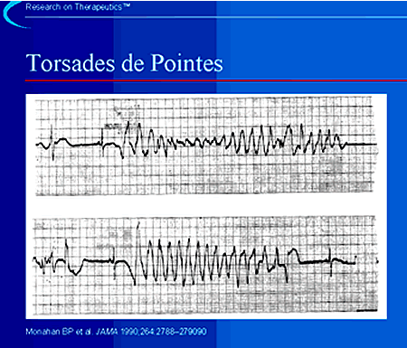
The first case we will consider is that of the potentially lethal arrhythmia, torsades de pointes, occurring in association with terfenadine (Seldane) use in a young woman.1
This ECG is a classic example of torsades de pointes, which is French for "twisting of the points." Torsades is a form of ventricular tachycardia that can most often be due to medications. The QRS complexes during this rhythm tend to show a series of "points up" followed by "points down" often with a narrow waist between. Recognition and reporting of this arrhythmia in association with terfenadine, astemizole (Hismanal), cisapride (Propulsid), grepafloxacin (Raxar), and mibefradil (Posicor) ultimately led to the removal of these medications from the market.
1Monahan BP, Ferguson CL, Cleave ES, Lloyd BK, Troy J, Cantilena LR. Torsade de pointes occurring in association with terfenadineuse. JAMA 1990;264:2788–2790.

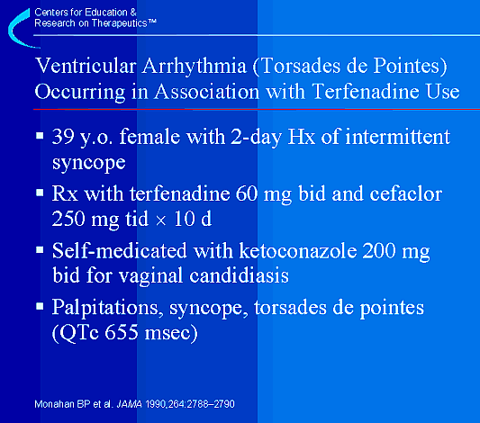
A 39-year-old female was evaluated for episodes of syncope and light-headedness that began two days prior to her hospital admission.1 The history was consistent with possible cardiovascular causes, and the patient was admitted and placed on telemetry where the preceding rhythm strip was observed.
Ten days prior to admission she had been prescribed terfenadine (Seldane—an antihistamine) 60 mg twice-a-day and cefaclor (Ceclor—a cephalosporin antibiotic) 250 mg three-times-a-day. On the eighth day of terfenadine therapy the patient began a self-medicated course of ketoconazole (Nizoral—an azole antifungal) at 200 mg twice-a-day for vaginal candidiasis. She was also taking medroxyprogesterone acetate at a dosage of 2.5 mg a-day. Upon admission to the hospital the patient was noted to have a QTc interval of 655 milliseconds (normal is less than 440 milliseconds). During the hospitalization the patient experienced near syncopal episodes associated with torsades de pointes noted on telemetry.
After discontinuing the medications, the QTc interval normalized. She had no further episodes of torsades de pointes, and she was discharged with no recurrence of syncope.
1Monahan BP, Ferguson CL, Cleave ES, Lloyd BK, Troy J, Cantilena LR. Torsade de pointes occurring in association with terfenadineuse. JAMA 1990;264:2788–2790.

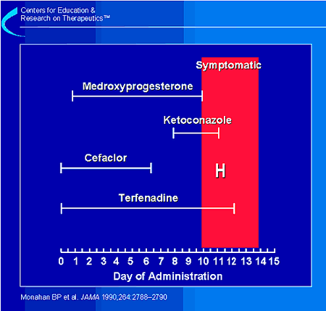
This figure illustrates the time course of the medications that the patient took.1 In relation to when the symptoms started, the most recently prescribed drug was ketoconazole. Ketoconazole has not been associated with development of torsades de pointes when used by itself. How did ketoconazole interact with terfenadine to cause QT prolongation and torsades de pointes in this patient? That question will be answered during the course of this module.
1Monahan BP, Ferguson CL, Cleave ES, Lloyd BK, Troy J, Cantilena LR. Torsade de pointes occurring in association with terfenadineuse. JAMA 1990;264:2788–2790.

ADRs: Prevalence and Incidence
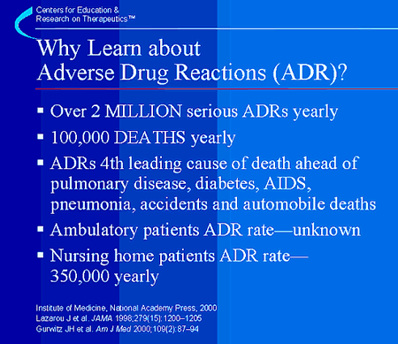
The first question healthcare providers should ask themselves is "why is it important to learn about ADRs?" The answer is because ADRs are one of the leading causes of morbidity and mortality in health care. The Institute of Medicine reported in January of 2000 that from 44,000 to 98,000 deaths occur annually from medical errors.1 Of this total, an estimated 7,000 deaths occur due to ADRs. To put this in perspective, consider that 6,000 Americans die each year from workplace injuries.
However, other studies conducted on hospitalized patient populations have placed much higher estimates on the overall incidence of serious ADRs. These studies estimate that 6.7% of hospitalized patients have a serious adverse drug reaction with a fatality rate of 0.32%.2 If these estimates are correct, then there are more than 2,216,000 serious ADRs in hospitalized patients, causing over 106,000 deaths annually. If true, then ADRs are the 4th leading cause of death—ahead of pulmonary disease, diabetes, AIDS, pneumonia, accidents, and automobile deaths.
These statistics do not include the number of ADRs that occur in ambulatory settings. Also, it is estimated that over 350,000 ADRs occur in U.S. nursing homes each year.3 The exact number of ADRs is not certain and is limited by methodological considerations. However, whatever the true number is, ADRs represent a significant public health problem that is, for the most part, preventable.
1Committee on Quality of Health Care in America: Institute of Medicine. To err is human: building a safer health system. Washington, D.C.: National Academy Press; 2000. 2Lazarou J, Pomeranz B, Corey PN. Incidence of adverse drug reactions in hospitalized patients: A meta-analysis of prospective studies. JAMA 1998;279:1200–1205. 3Gurwitz JH, Field TS, Avorn J, McCormick D, Jain S, Eckler M, et al. Incidence and preventability of adverse drug events in nursing homes. Am J Med 2000;109(2):87–94.

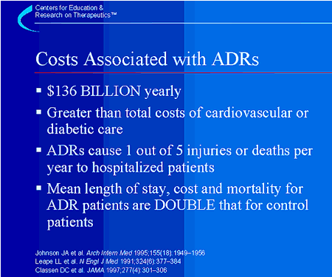
We can next ask ourselves, what are the health care costs associated with adverse drug reactions? Again, methodological constraints limit making completely accurate estimates, but one estimate of the cost of drug-related morbidity and mortality is $136 billion annually,1 which is more than the total cost of cardiovascular or diabetic care in the United States. In addition, one out of 5 injuries or deaths per year to hospitalized patients may be as a result of ADRs.2 Finally, a two-fold greater mean length of stay, cost and mortality has been reported for hospitalized patients experiencing an ADR compared to a control group of patients without an adverse drug reaction.3
1Johnson JA, Bootman JL. Drug-related morbidity and mortality. A cost-of-illness model. Arch Intern Med 1995;155(18):1949–1956. 2Leape LL, Brennan TA Laird N, Lawthers AG ,Localio AR, Barnes BA et al. The nature of adverse events in hospitalized patients. Results of the Harvard Medical Practice Study II. N Engl J Med 1991;324(6):377–384. 3Classen DC , Pestotnik SL, Evans RS, Lloyd JF, Burke JP. Adverse drug events in hospitalized patients. Excess length of stay, extra costs, and attributable mortality. JAMA 1997;277(4):301–306.

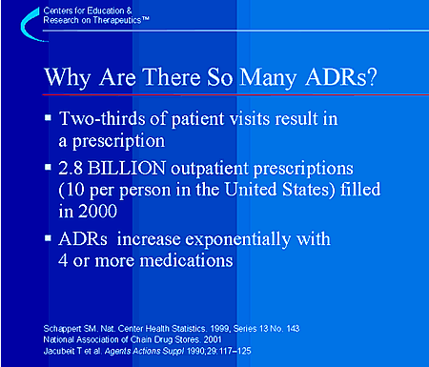
Why are there so many ADRs? There are many reasons. Here are just a few.
First, more drugs—and many more combinations of drugs—are being used to treat patients than ever before. To exemplify this point, 64% of all patient visits to physicians result in prescriptions.1
Secondly, 2.8 billion prescriptions were filled in the year 2000. 2 That is about 10 prescriptions for every person in the United States.
Finally, the rate of ADRs increases exponentially after a patient is on 4 or more medications.3
Efforts to reduce polypharmacy are important but for many patients, the number of medications cannot always be reduced without doing harm. That is why it is important to understand the basis for drug interactions. This will allow us to make the most appropriate choices in prescribing and avoiding preventable ADRs.
1Schappert SM. Ambulatory care visits to physician offices, hospital outpatient departments, and emergency departments: United States,1997. National Center for Health Statistics. Vital Health Stat. 1999;13(143). 2National Association of Chain Drug Stores. 2000 community pharmacy results. 2001. Alexandria, VA. 3Jacubeit T, Drisch D, Weber E. Risk factors as reflected by an intensive drug monitoring system. Agents Actions 1990;29:117–125.

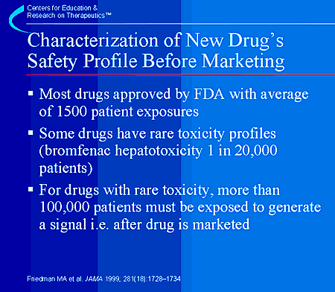
It is worth considering how well a drug’s safety is defined prior to its approval and marketing. This will indicate how confident practitioners can be that a new drug’s safety profile has been fully defined.
Most new drugs are approved with an average of 1,500 patient exposures and usually for only relatively short periods of time. However, some drugs cause serious ADRs at very low frequencies and would require many more exposures to detect the reaction. For example, bromfenac (Duract) was a non-steroidal anti-inflammatory agent (NSAID) that was removed from the market in 1998, less than 1 year after it was introduced. Bromfenac caused serious hepatotoxicity in only 1 in 20,000 patients taking the drug for longer than 10 days.1 To reliably detect the toxic effects of a drug with a 1 in 20,000 adverse drug reaction frequency, the new drug application database would have to include 100,000 patient exposures. A drug that is tested in a few thousand people 11 may have an excellent safety profile in those few thousand patients. However, within a short time after entering the market, the drug may be administered to several million patients. That means that for drugs that cause rare toxicity, their toxicity can only be detected after, not before, marketing.
If one case of hepatotoxicity is seen during pre-marketing testing, it can be difficult, if not impossible, to ascertain whether it was secondary to the drug or just the background rate of disease that is seen in the population.
So, the safety profile for new drugs that come on the market is never totally defined because new drugs are studied only in relatively small and homogenous patient populations. The complete safety profile of a new drug will be defined only after it has been approved and is in use on the market.
1Friedman MA, Woodcock J, Lumpkin MM, Shuren JE, Hass AE, Thompson LJ. The safety of newly approved medicines: do recent market removals mean there is a problem? JAMA 1999; 281(18):1728–1734.

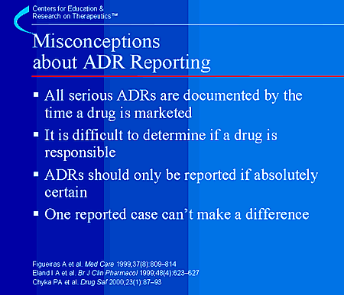
Health care providers have misconceptions about reporting ADRs.1–3 These misconceptions include the ideas that: 1) All serious ADRs are documented by the time a drug is marketed; 2) It is hard to determine if a drug is responsible for the ADR; 3) ADRs should only be reported if absolute certainty exists that the ADR is related to a particular drug; and, finally, 4) One case reported by an individual physician does not contribute to medical knowledge. Let’s look at each one of these points.
1) As we have seen, rare ADRs are usually NOT documented by the time a drug is marketed.
2) It can be hard to determine if an individual drug caused a reaction in a complicated patient receiving multiple medications. However, the temporal relationship of a reaction with regard to the administration of a new medication can be helpful. Also, biological plausibility (asking if the drug’s mechanism of action makes this possible or likely) can also be helpful. The bottom line is, even when in doubt about whether a drug caused the reaction, report it.
3) A suspicion of an adverse drug reaction should be reported. A health care provider does not have to be absolutely certain that a drug caused a reaction. All reports contribute to the heightening of the awareness of FDA safety scientists as they monitor all of the evidence to evaluate the potential for drug-related toxicity.
4) One individual report CAN make a difference. Many drug withdrawals began with one clinical report that initiated further investigation. In the example case in this module, a single report ultimately led to the removal of terfenadine from the market. This report potentially saved many lives and led to a better understanding of the mechanism involved in causing torsades de pointes. Almost all drugs are now evaluated prior to being released on the market for their potential to induce cardiac arrhythmias, also as a result of this single case report.
1Figueiras A, Tato F, Fontainas J, Gestal-Otero JJ. Influence of physicians’ attitudes on reporting adverse drug events: a case-control study. Med Care 1999;37(8):809-814. 2Eland IA, Belton KJ, van Grootheest AC, Meiners AP, Rawlins MD, Stricker BH. Attitudinal survey of voluntary reporting of adverse drug reactions. Br J Clin Pharmacol 1999;48(4):623–627. 3Chyka PA, McCommon SW. Reporting of adverse drug reactions by poison control centres in the US. Drug Saf 2000;23(1):87–93.

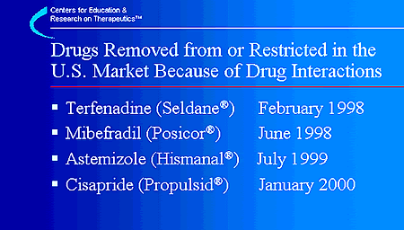
The inability of the FDA to effectively warn health care providers and patients about drug interactions and our inability to translate existing knowledge into changes in prescribing have resulted in huge economic consequences for the pharmaceutical industry and the loss from the marketplace of effective drugs, including terfenadine, mibefradil, astemizole, and cisapride.
These 4 drugs were removed from the market or restricted in their use because it became clear that they continued to be prescribed in an unsafe manner, even after multiple warning letters were disseminated by the manufacturer and the FDA to health care professionals concerning their proper use. Each of these drugs has value in the pharmaceutical marketplace, and each has value to patients. However, because the manufacturer and the FDA could not prevent co-prescription of these drugs with interacting drugs resulting in fatal interactions, the risk associated with continued widespread availability could not be justified.

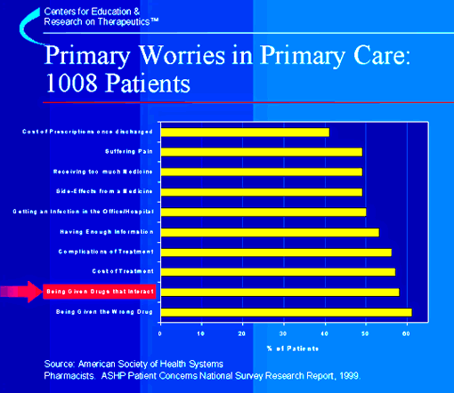

This figure shows data from a national survey conducted in 1999 by the American Society of Health Systems Pharmacists (ASHP)1 that evaluated patient concerns about health systems. This was a random telephone survey of 1,008 adults. Although the respondents were very concerned about suffering from pain and the cost of filling prescriptions, they were most concerned about being given the wrong drug or that a drug interaction would occur. The public in general has a much greater level of concern about ADRs than most health care providers would suspect. These data demonstrate that drug interactions and reactions are not only a concern to health care providers but to patients as well.
1American Society of Health Systems Pharmacists. ASHP Patient Concerns National Survey Research Report. 1999. Bethesda, MD.

Types of Drug Interactions
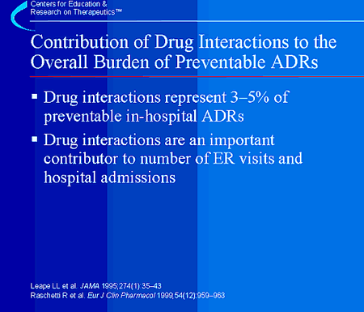
The previous slides have reviewed information about the magnitude of adverse drug reactions and the burden they place on the health care system. How much do drug interactions contribute to the total number of preventable ADRs?
Again, estimates of the numbers of patients injured due to drug interactions vary widely. However, some reasonable estimates come from the work of Dr. Lucien Leape and colleagues.1 In a systems analysis of ADRs, they estimated that drug-drug interactions represent from 3–5% of all in-hospital medication errors. Drug interactions are also an important cause of patient visits to emergency departments.2
1Leape LL, Bates DW, Cullen DJ, Cooper J, Demonaco HJ, Gallivan T, et al. Systems analysis of adverse drug events. ADE Prevention Study Group. JAMA 1995;274(1):35–43. 2Raschetti R, Morgutti M, Menniti-Ippolito F, Belisari A, Rossignoli A, Longhini P, et al. Suspected adverse drug events requiring emergency department visits or hospital admissions. Eur J Clin Pharmacol 1999;54(12):959–963.

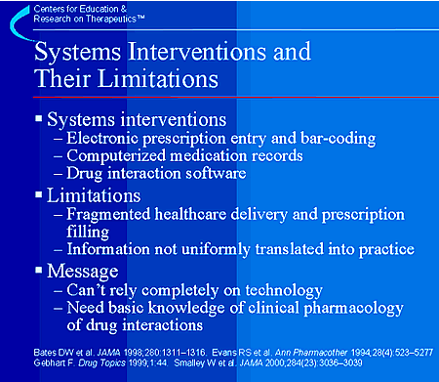
Recent publications have shown that many adverse drug reactions can be prevented and detected through the use of systems interventions. For example, many health systems have instituted new technologies to minimize patient injury due to medication errors and drug-drug interactions.1–3 Tools like computerized physician order and prescription entry 1 and bar coding systems 3 have demonstrated tangible benefits. The potential for reducing medication errors by using computerized medical records as well as drug-interaction screening software that detects and alerts the physician and/or pharmacist to potentially serious drug interactions has been recognized.4
These technological solutions do have limitations, however. The fragmentation of healthcare delivery may result in incomplete records. More significant is the fact that, although this information is avail-able, it is not uniformly or optimally incorporated into decision making. This is exemplified in the observation by Cavuto et al. that pharmacists filled prescriptions for drug combinations that were known to interact even though computerized drug interaction software was in place.5 This problem persists as shown in the 2000 paper by Smalley et al. on prescription errors with cisapride.6
These findings should reinforce the need for the health care practitioner to develop their own systems approach to prescribing without creating undesirable drug interactions. A fundamental understanding of the clinical pharmacology of drug interactions and a framework for avoiding preventable drug interactions remains critically important. Thus we need to overlay technologic solutions on a base that is strong in basic principles of clinical pharmacology and drug interactions. Incorporation of up-to-date computerized databases is valuable, and frequent consultation with other members of the healthcare team, such as nurses and pharmacists, is essential.
1Bates DW, Leape LL, Cullen DJ ,Laird N, Petersen LA, Teich JM et al. Effect of computerized physician order entry and a team intervention on prevention of serious medication errors. JAMA 1998;280(15):1311–1316. 2Evans RS, Pestotnik SL, Classen DC, Horn SD, Bass SB, Burke JP. Preventing adverse drug events in hospitalized patients. Ann Pharmacother 1994;28(4):523–527. 3Gebhart F. VA facility slashes drug errors via bar-coding. Drug Topics 1999;1:44. 4Committee on Quality of Health Care in America: Institute of Medicine. To err is human: building a safer health system. Washington, D.C.: National Academy Press,2000. 5Cavuto NJ, Woosley RL, Sale M. Pharmacies and prevention of potentially fatal drug interactions. JAMA 1996;275: 1086–1087. 6Smalley W, Shatin D, Wysowski DK, Gurwitz J Andrade SE, Goodman M, et al. Contraindicated use of cisapride: impact of food and drug administration regulatory action. JAMA 2000;284(23):3036–3039.

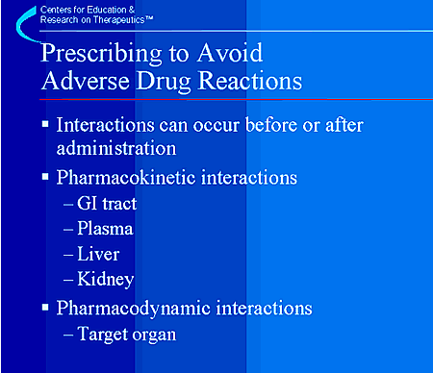

We will discuss an approach to prescribing drugs in ways that avoid adverse drug interactions as a cause for preventable medication errors.
Drug interactions can occur via several mechanisms:
• Drugs interactions can occur even before drugs enter the body due to formulation incompatibility, or at any point in the process of absorption, distribution metabolism, and elimination.
• Drugs can bind to each other in the GI tract, preventing absorption, and reducing systemic availability.
• In theory, drugs could interact in the plasma via protein-bumping reactions but, despite the emphasis placed on these in many texts and pharmacology courses, there are no known clinically relevant examples in which this mechanism is responsible.
• A large number of important interactions do occur in the liver and GI tract due to changes in the rates of drug metabolism brought about by other medicines that are inducers or inhibitors of drug metabolism. We will be looking at this topic in depth.
• A few interactions occur through competition at drug transporters.
• Finally, interactions can occur at the level of drug action, such as the combination of verapamil, a calcium channel blocker, and a beta-blocker. Both slow the heart rate by different mechanisms, and the combination is relatively contraindicated because heart block can result. Because of this interaction many textbooks and computer pro-grams warn against concomitant use of any beta-blocker and any calcium channel blocker. This creates a great deal of confusion and distrust of drug interaction warnings, because most health care providers know that drugs in these two classes are often employed successfully and safely in patients with hypertension.

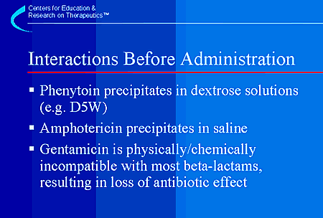
The next few slides will review some of the mechanisms for drug interactions in more detail. Several examples of drug interactions that occur prior to drug administration are listed here. When phenytoin is added to solutions of dextrose, a precipitate forms and the phenytoin falls to the bottom of the IV bag as an insoluble salt. When this happens, it is no longer available to control seizures. Amphotericin is still used widely as a urinary bladder perfusion to treat aggressive fungal infections. If it is administered in saline, the drug precipitates and can erode through the bladder wall if not removed. The clinical presentation of such cases is an acute abdomen due to perforation of the bladder.1 Lastly, it is recommended that aminoglycosides not be co-mixed in IV fluids with betalactam antibiotics. This can markedly reduce antibiotic efficacy.
1Personal Communication, David Flockhart, MD, PhD, University of Indiana, July 2001.

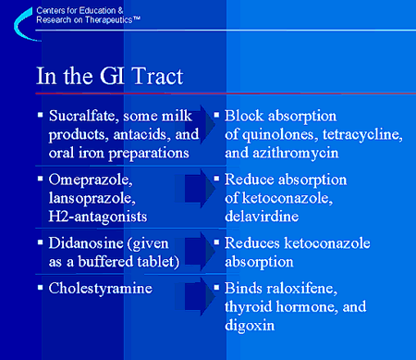
A number of interactions occur in the GI tract and reduce the entry of drugs into the systemic circulation.
Particularly notable among these is the ability of aluminum-containing medicines such as sucralfate (Carafate) and antacids to reduce the absorption of expensive and potentially life-saving antibiotics like ciprofloxacin (Cipro) and azithromycin (Zithromax). Women taking iron supplements often do not consider them as a medicines, and should be specifically questioned about whether they are taking iron if they are to be prescribed a quinolone or azithromycin. Drugs such as ketoconazole (Nizoral) and delavirdine (Rescriptor) require an acidic environment to be in the non-charged form that is preferentially absorbed. Solubility is drastically reduced in neutral or basic medications such as omeprazole (Prilosec), lansoprazole (Prevacid), or H2-antagonists that raise the stomach’s pH.

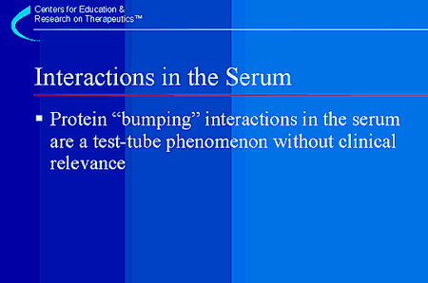
Some drugs can "bump" other drugs off proteins in the plasma and result in an increased amount of free drug, but this is only transient because the usual elimination mechanisms respond by increasing the rate of elimination. There is no clinically relevant protein-bumping interaction that has been reported. The previously cited examples have subsequently been shown to be due to inhibition of elimination, not plasma protein displacement.

Drug Metabolism
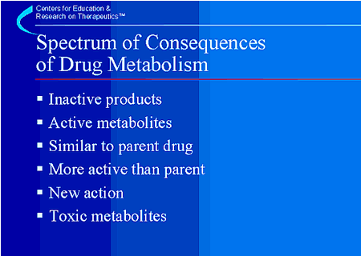
The next few slides will focus on drug metabolism. Some important preventable drug interactions are due to their effects on drug metabolizing enzymes, resulting in either inhibition (reduced activity) of the enzyme or induction (increased activity) of the enzyme. There are many potential consequences of changes in drug metabolism for a given drug. It is made more complex by the fact that there are multiple pathways of metabolism for many drugs.
The majority of drugs that are metabolized are converted to inactive metabolites. This is the most common fate for most drugs. Of the remaining drugs, some are converted to metabolites that retain the same activity as the parent. An example of this is fexofenadine (Allegra), the active metabolite of terfenadine that has equal potency at the histamine receptor and now is on the market and used clinically for allergic rhinitis. However, fexofenadine is more than 50 times less active in blocking potassium channels in the heart and therefore, unlike terfenadine, does not cause torsades de pointes.1
In some cases the metabolites are actually more potent than the parent. For example, a pro-drug such as enalapril must be hydrolyzed to enalaprilat to become active.
In some cases, the metabolites have entirely new pharmacologic actions not seen with the parent drug. Metabolites can also be toxic, such as the metabolites of acetaminophen, which can cause liver failure, or the metabolite of meperidine, which can cause seizures.
Inhibition of metabolism could result in potentially toxic concentrations of the parent compound. On the other hand, if the parent drug needs to be metabolized to the active compound and metabolism is inhibited, then a therapeutic failure could result. This happens, for example, if codeine, a prodrug, is not metabolized to morphine. Induction of drug metabolizing enzymes could similarly result in a subtherapeutic effect by reducing drug levels below that required for efficacy.
1Woosley RL, Chen Y, Freiman JP, Gillis RA. Mechanism of the cardiotoxic actions of terfenadine. JAMA 1993;269(12):1532–1536.

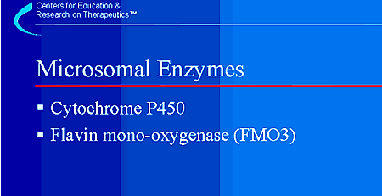
The major group of enzymes in the liver that metabolize drugs can be isolated in a subcellular fraction termed the microsomes. The largest and most important of these enzymes are the cytochrome P450 family of enzymes. The origin of the term "cytochrome P450" will be explained later. In addition to cytochrome P450, there are other enzymes in microsomes such as flavin monooxygenase (termed FMO3). These are also responsible for metabolism of some drugs, but have not been as well characterized as the cytochrome P450 system, and will not be discussed further in this presentation.

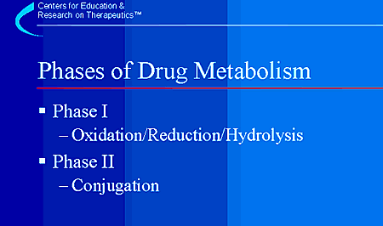
Drug metabolism is generally classified in two phases, termed Phase I and Phase II.
Phase I reactions include oxidation or reduction reactions, usually through the actions of cytochrome P450 oxidative enzymes or reductases. These enzymes prepare very lipophilic molecules for Phase II reactions by creating a conjugation site, often a reactive group such as an hydroxyl group.
Phase II reactions "conjugate" a water soluble entity such as acetate or glucuronate onto the drug at the newly created or pre-existing sites, forming a more polar and water soluble metabolite that can be more easily excreted in the urine and/or bile.

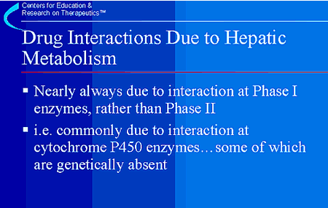
There are some characteristics of drug metabolism that can help predict important interactions due to inhibition of metabolism. Since Phase II reactions generally result in conjugation of a drug to a water-soluble group like a sugar, peptide (glutathione) or sulfur group, and, because there is a large excess of these groups in well nourished cells, these reactions are rarely rate-limiting. Thus, they are rarely involved in drug interactions. In contrast, the Phase I reactions carried out by cytochrome P450 enzymes, flavin monooxygenases, and reductases are more frequently rate-limiting. These are the target of clinically significant drug interactions, such as the inhibition of cyclosporine metabolism by erythromycin.
Six cytochrome P450 isoforms have been well characterized in terms of drug metabolism in humans. These will be reviewed in the next few slides. Of note, 3 of these isoforms—CYP2C9,CYP2C19, and CYP2D6—can be genetically absent.

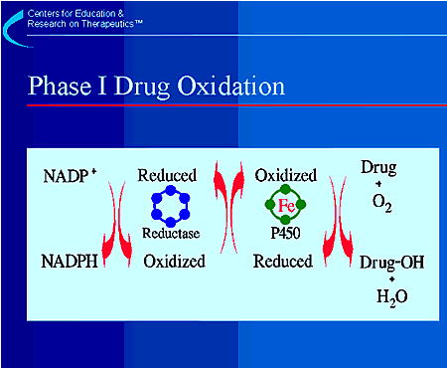
Phase I oxidative enzymes are mostly found in the endoplasmic reticulum, a subcellular organelle in the liver. The predominant enzymes responsible for Phase I reactions are those involving the microsomal mixed function oxidation system. This system requires the presence of NADPH and NADPH-cytochrome P450 reductase. "Cytochrome P450" is a superfamily of enzymes that is the terminal oxidase of this oxidation system. These enzymes are companions and part of a cascade that shuttles electrons from molecular oxygen to oxidize drugs. "Cytochrome" means colored cells, and the enzymes contain iron, which gives the liver its red color. "P450" comes from the observation that the enzyme absorbs a very characteristic wavelength (450 nm) of UV light when it is exposed to carbon monoxide.
There are many different isoforms of cytochrome P450, but 6 have been especially well characterized in terms of clinically relevant drug metabolism and will be discussed here.
As shown in the slide, the enzymes function in a cascade of oxidation-reduction reactions that ultimately result in one atom of oxygen being incorporated into an oxidized metabolite, such as the hydroxylated form of drug shown in the slide.

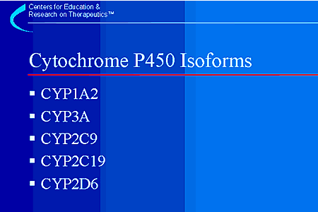
This slide lists the major cytochrome P450 isozymes that are responsible for metabolism of drugs in humans. These enzymes will be reviewed in detail. Because many drugs are metabolized principally by these enzymes, important interactions between drugs can be predicted by using a list of drugs that are inhibitors or inducers of that enzyme. This simplifies the search for interacting drugs and provides a framework for prediction of interactions. Next we will review how these enzymes are named.

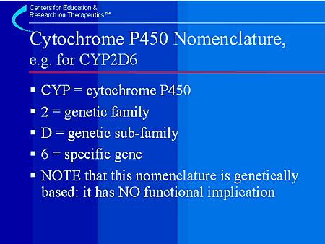
Cytochrome P450s were named by molecular biologists and protein chemists. The enzymes are named according to families that are defined by the similarity of their amino acid sequence.
A very important principle in pharmacology applies in this case: A small change in the structure of a drug or a protein that interacts with it can result in major changes in the actions of the drug. Because of this great sensitivity, small changes in amino acid sequence can result in huge changes in substrate specificity for the cytochrome P450 enzymes. For example, 2C19 is the principal metabolic enzyme for omeprazole (Prilosec) metabolism, but a closely related enzyme, 2C9, has no catabolic effect on omeprazole. Thus, little functional similarity is imparted by the similarity in amino acid sequence on which this nomenclature is based. However, as will be seen later, there is some concordance between classes of drugs and the P450 family that metabolizes them. The focus of the subsequent slides will be to outline the role of the cytochrome P450 isozymes in metabolism of commonly used drugs and to identify tools that can be used in clinical practice to avoid cytochrome P450-mediated drug interactions.

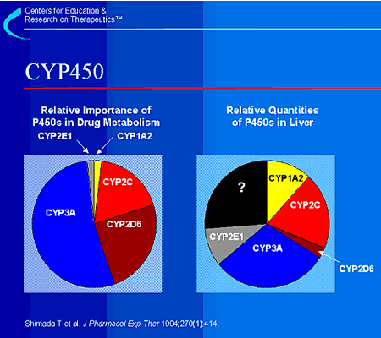
The graph on the left lists the major isoforms of CYP450 and their relative roles in drug metabolism (not relative amounts found in the liver) based upon the number of drugs that are known to be metabolized by that particular isozyme. CYP3A is responsible for the metabolism of the largest number of drugs followed by CYP2D6. The graph on the right summarizes the relative quantity of specific P450 families found in the liver.1 The CYP3A family is present in the largest amounts. CYP2D6 accounts for less than 2% of the total content of P450 in the liver, but as shown on the left, is responsible for the metabolism of a large fraction of drugs. A large amount of cytochrome P450 has not yet been characterized.
There is tremendous variability between individuals in terms of expression of cytochrome P450 isozymes. For example, CYP2D6 is not present at all in some livers.
Note: 2C on the graph on the right refers to both CYP2C9 and CYP2C19.
1Shimada T, Yamazaki H, Mimura M, Inui Y, Guengerich FP. Interindividual variations in human liver cytochrome P-450 enzymes involved in the oxidation of drugs, carcinogens and toxic chemicals: studies with liver microsomes of 30 Japanese and 30 Caucasians. J Pharmacol Exp Ther 1994;270(1):414–423.

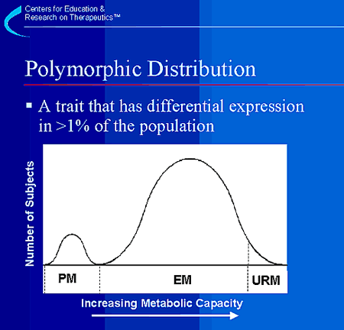
The cytochrome P450 enzymes have 3 interesting properties that often make it possible to predict drug interactions. First, some people have mutations in one or more of the nucleic acids in the DNA sequence expressing a given cytochrome P450 isozyme. As a result, the enzyme may be absent or have low, or no, metabolizing activity for drugs that are usually metabolized by that enzyme. If the mutation is relatively common (more than 1%) it creates a polymorphism—this is a trait that has genetic variation that results in more than a single population being represented in greater than 1% of the total population. It literally means that the distribution of the trait has “multiple” “forms,” i.e. “poly” “morphic.” At least 3 of the cytochrome P450s that we will be discussing (2D6, 2C19, 2C9) are polymorphic in their distribution. People expressing a polymorphism will therefore metabolize drugs at a different rate than the rest of the population. This graph demonstrates a population drug metabolism distribution for CYP2D6. On the graph, PM means poor metabolizer, EM means extensive metabolizer, which is the normal or usual phenotype, and URM means ultra-rapid metabolizer. Approximately 7% of the U.S. population has a genetic defect in CYP2D6 that results in a poor metabolizer phenotype. Ultra-rapid metabolizers usually do not appear as a separate distribution in most phenotypic data but are important because a usual dose of drug in these people will be cleared more quickly than in the rest of the population and will result in lower blood levels of the drug and, perhaps, less therapeutic effect. For CYP2D6, it is known that these individuals have very high activity because they have multiple copies of the CYP2D6 gene (up to13 copies have been reported). Second, people that have usual drug metabolizing ability (EM) can become phenotypic poor metabolizers if they are given a substance (drug or food as we will see later) that inhibits the enzyme. So if two drugs are given that are metabolized by the same enzyme, and one inhibits the enzyme, the second drug can accumulate to higher and potentially toxic levels. Third, several of the cytochrome P450 isozymes can be “induced” to have increased activity. If this occurs, metabolism of any drug that is a substrate for that isozyme will be metabolized more quickly resulting in lower plasma concentrations of the drug. This may also reduce the efficacy of the drug. Also, if the drug is metabolized to a toxic compound, the toxic metabolite may accumulate to higher levels. The P450 isozymes will now be reviewed in more detail. The laminated card in the pocket of the module can be used as a reference for the next few slides.

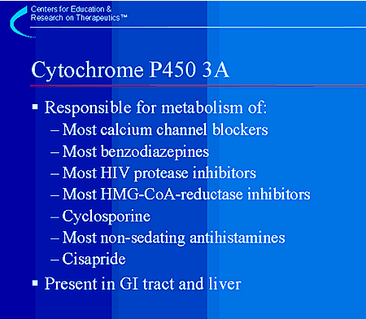
CYP3A is responsible for metabolizing the greatest number of marketed drugs. These include a wide range of important medications including cyclosporine and HIV protease inhibitors, as well as cisapride (Propulsid) and the no longer marketed non-sedating antihistamines terfenadine (Seldane) and astemizole (Hismanal). Although CYP3A is not polymorphic in its distribution (it doesn’t have a distinctly separate population as seen on the previous graph), its activity varies over 50-fold in the general population. CYP3A has been recently reviewed.1
CYP3A is the drug metabolizing pathway involved in the case of torsades de pointes described at the beginning of the module. Terfenadine, one of the first non-sedating antihistamines, is metabolized by CYP3A to fexofenadine. When the CYP3A-mediated metabolism of terfenadine is inhibited by ketoconazole, as in the case described, terfenadine accumulates to high levels. At these high levels, terfenadine is a blocker of potassium channels in the heart.2 Potassium channels are important for repolarization of the heart. Once these channels are blocked, QT interval on the electrocardiogram can be prolonged and torsades de pointes can develop, as was seen in this case. Many commonly used drugs can inhibit this enzyme as we will see in the next slide. This important enzyme has been the basis for most of the fatal drug interactions that have gained so much publicity in recent years. For terfenadine, as well as astemizole and cisapride, recognition and reporting of torsades de pointes in association with the drug and its interactions ultimately led to withdrawal of these drugs from the market.
The vast majority of drugs that may cause cardiac arrhythmias by prolonging the QT interval are metabolized by cytochrome P450 3A. While the biological basis for this remains unclear, it does make it easier to remember!
Also note that CYP3A is found in the liver and also in the GI tract. Drugs that are substrates of CYP3A can be extensively metabolized in the GI tract, and ,in fact, the GI tract is responsible for a large part of the metabolism that was formerly attributed totally to the liver! Inhibition of GI tract CYP3A also results in higher plasma levels of substrate drugs.
1Thummel KE, Wilkinson GR. In vitro and in vivo drug interactions involving human CYP3A. Annu Rev Pharmacol Toxicol 1998;38:389–430. 2Woosley RL, Chen Y, Freiman JP, Gillis RA. Mechanism of the cardiotoxic actions of terfenadine. JAMA 1993;269(12):1532–1536.

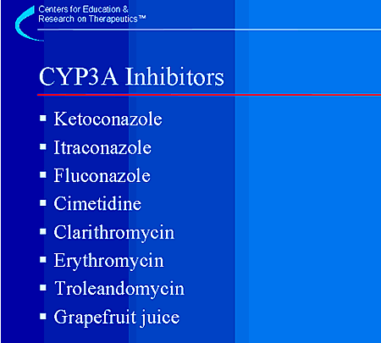
These are the important inhibitors of CYP3A that will make patients appear phenotypically to resemble poor metabolizers. Azole antifungal drugs, in general, are potent inhibitors of CYP3A, although fluconazole is a weak inhibitor and inhibits CYP3A only at high doses. All the macrolide antibiotics, except azithromycin, are also potent inhibitors of this cytochrome P450 isoform. Cimetidine is a broad, but relatively weak, inhibitor of many cytochrome P450 enzymes. Also, notice that a food, grapefruit juice, is listed as an inhibitor. The role of grapefruit juice in drug interactions will be discussed later.

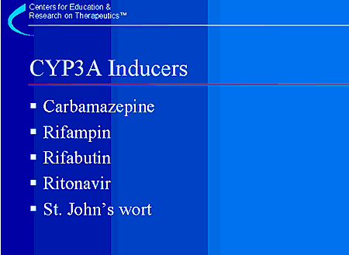
Several commonly used drugs have been characterized as inducers of CYP3A. Use of these drugs could potentially result in lack of therapeutic efficacy of a CYP3A substrate. Drug interactions with the herbal remedy St. John’s wort will be discussed later in the presentation.

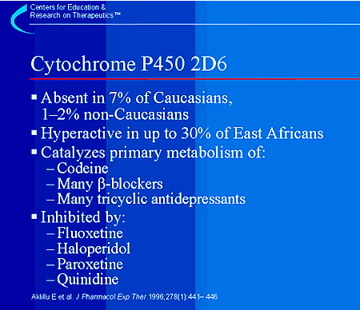
CYP2D6 metabolizes many of the cardiovascular and neurologic drugs in use today. Study of CYP2D6 has led to understanding the failure of codeine to relieve pain in some patients. Codeine is actually a pro-drug that is converted to morphine. Codeine itself is much less active as an analgesic, but causes nausea and other adverse effects. The absence of cytochrome P450 2D6 in 7% of Caucasians means that these individuals cannot metabolize codeine to the active metabolite, morphine, and therefore will get little, if any, pain relief from codeine.1 However, they will experience codeine’s adverse effects, particularly if the dose is increased in the futile attempt to obtain pain relief.
Thirty percent of Ethiopians studied had multiple copies of the 2D6 gene (up to13) and increased eynzyme activity resulting in ultrarapid metabolism.2 Ultra-rapid metabolism results in lower blood levels following a standard dose of any drug metabolized by this enzyme. Therefore these patients may have an inadequate response to standard dosages of ß-blockers, narcotic analgesics, or antidepressants and may require higher dosages for clinical effectiveness.
Several commonly used medications inhibit CYP2D6. These include quinidine3 as well as haloperidol and some other antipsychotics.4,5 The well-described pharmacokinetic interaction between selective serotonin reputake inhibitor (SSRI) antidepressants and tricyclic antidepressants appears to be due to the fact that fluoxetine and paroxetine are both potent inhibitors of CYP2D66,7 and render patients metabolically equivalent to people who do not have the enzyme. This increases the plasma levels of tricyclic antidepressants and increases the potential for side effects. In contrast, patients co-prescribed fluoxetine or paroxetine with codeine may experience no analgesic benefit, since codeine requires CYP2D6 for metabolism to morphine.
1Caraco Y, Sheller J, Wood AJ. Pharmacogenetic determination of the effects of codeine and prediction of drug interactions. J Pharmacol Exp Ther 1996; 278(3):1165–1174. 2Aklillu E, Persson I, Bertilsson L, Johansson I, Rodrigues F, Ingelman-Sundberg M. Frequent distribution of ultrarapid metabolizers of debrisoquine in an ethiopian population carrying duplicated and multiduplicated functional CYP2D6 alleles. J Pharmacol Exp Ther 1996;278(1):441–446. 3Branch RA, Adedoyin A, Frye RF, Wilson JW, Romkes M. In vivo modulation of CYP enzymes by quinidine and rifampin. Clin Pharmacol Ther 2000; 68(4):401–411. 4Shin JG, Kane K, Flockhart DA. Potent inhibition of CYP2D6 by haloperidol metabolites: stereoselective inhibition by reduced halo-peridol. Br J Clin Pharmacol 2001;51(1):45–52. 5Shin JG, Soukhova N, Flockhart DA. Effect of antipsychotic drugs on human liver cytochrome P-450 (CYP) isoforms in vitro: preferential inhibition of CYP2D6. Drug Metab Dispos 1999;27(9):1078–1084. 6Bergstrom RF, Peyton AL, Lemberger L. Quantification and mechanism of the fluoxetine and tricyclic antidepressant interaction. Clin Pharmacol Ther 1992;51(3):239–248. 7Leucht S, Hackl HJ, Steimer W, Angersbach D, Zimmer R. Effect of adjunctive paroxetine on serum levels and side-effects of tricyclic antidepressants in depressive inpatients. Psychopharmacology (Berl) 2000;147(4):378–383.

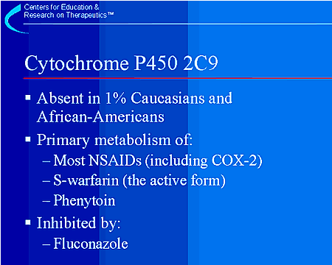
CYP2C9 has a polymorphic distribution in the population and is missing in 1% of Caucasians. It is the major enzyme responsible for metabolism of many of the non-steroidal anti-inflammatory drugs (NSAIDs), including the second generation cyclooxygenase-2 (COX-2) specific inhibitors. A number of other important medications have their metabolism primarily catalyzed by CYP2C9. An important drug metabolized by this enzyme is warfarin (Coumadin), and almost all inter-patient variability in warfarin levels and anticoagulant effects can be explained on the basis of CYP2C9 activity (not the differences in protein binding as originally thought).
The azole antifungal agent fluconazole (Diflucan) is a potent inhibitor of CYP2C9. Fluconazole, at conventional doses, abolishes CYP2C9 activity.
An interaction between fluconazole and warfarin results in at least a two-fold increase in warfarin blood level, a reduction in warfarin clearance, and increased anticoagulation.1 Clinical studies have identified a significant interaction between fluconazole and celecoxib (Celebrex), leading to a twofold increase in celecoxib plasma concentrations.2 A clinical pharmacokinetic study demonstrated an increase in phenytoin area under the plasma concentration curve (AUC) following fluconazole administration,3 and symptomatic phenytoin toxicity has been reported with concomitant administration of fluconazole and phenytoin.4
1Black DJ, Kunze KL , Wienkers LC, Gidal BE, Seaton TL, McDonnell ND, et al. Warfarin-fluconazole. II. A metabolically based drug interaction: in vivo studies. Drug Metab Dispos 1996;24(4):422–428. 2Celebrex. Physicians’Desk Reference. Montvale, NJ: Medical Economics Company, Inc., 2001:2482–2485. 3Touchette MA, Chandrasekar PH, Milad MA, Edwards DJ. Contrasting effects of fluconazole and ketoconazole on phenytoin and testosterone disposition in man. Br J Clin Pharmacol 1992;34(1):75–78. 4Cadle RM, Zenon GJ,III, Rodriguez-Barradas MC, Hamill RJ. Fluconazole-induced symptomatic phenytoin toxicity. Ann Pharmacother 1994;28(2):191–195.

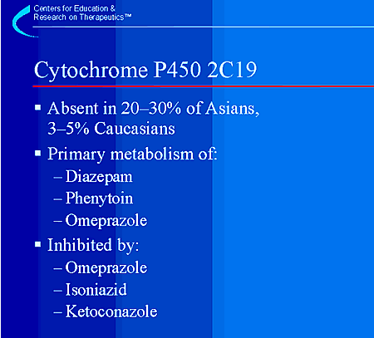
Cytochrome P450 2C19 is notable because of its genetic absence in such a high percentage of Asians (approximately 20–30%). This enzyme metabolizes many anticonvulsants, diazepam (Valium), omeprazole (Prilosec) and several of the tricyclic antidepressants. Asians have reduced clearance of diazepam compared to Caucasians,1 and, in fact, a survey of Asian and Western physicians demonstrated the use of lower doses of diazepam in Asians.2 Asian patients may have a lower omeprazole dosage requirement for effective treatment of Helicobacter pylori. According to the omeprazole package insert, Asians have about a four-fold increase in the AUC of omeprazole compared to Caucasians, and the labeling recommends that one should consider dosage adjustment.3 In addition, the poor metabolizer genotype for CYP2C19 resulted in a higher cure rate for H. pylori (100%) than the rapid metabolizer genotype (28.6%) in an Asian population treated with omeprazole as part of dual therapy.4 Similar results have been shown more recently with proton pump inhibitors in a triple therapy regimen.5
Ketoconazole6 and omeprazole7 are inhibitors of CYP2C19 and have the potential for clinically significant interactions with substrates of CYP2C19 such as diazepam8 or phenytoin.9 Isoniazid, used to treat tuberculosis, is an inhibitor of CYP2C1910 and should be prescribed cautiously to patients taking phenytoin and other drugs metabolized by CYP2C19.
1Ghoneim MM, Korttila K, Chiang CK ,Jacobs L ,Schoenwald RD, Mewaldt SP, et al. Diazepam effects and kinetics in Caucasians and Orientals. Clin Pharmacol Ther 1981;29(6):749–756. 2Rosenblat R, Tang SW. Do Oriental psychiatric patients receive different dosages of psychotropic medication when compared with occidentals. Can J Psychiatry 1987;32(4):270–274. 3Prilosec. Physicians’ Desk Reference. Montvale, NJ: Medical Economics Company, Inc.;2001:587–591. 4Furuta T, Ohashi K, Kamata T, Takashima M ,Kosuge K, Kawasaki T, et al. Effect of genetic differences in omeprazole metabolism on cure rates for Helicobacter pylori infection and peptic ulcer. Ann Intern Med 1998; 129(12):1027–1030. 5Furuta T, Shirai N, Takashima M, Xiao F, Hanai H, Sugimura H, et al. Effect of genotypic differences in CYP2C19 on cure rates for Helicobacter pylori infection by triple therapy with a proton pump inhibitor, amoxicillin, and clarithromycin. Clin Pharmacol Ther 2001;69(3):158–168. 6Atiba JO, Blaschke TF, Wilkinson GR. Effects of ketoconazole on the polymorphic 4-hydroxylations of S-mephenytoin and debrisoquine. Br J Clin Pharmacol 1989;28(2):161–165. 7Ko JW, Sukhova N, Thacker D, Chen P, Flockhart DA. Evaluation of omeprazole and lansoprazole as inhibitors of cytochrome P450 isoforms. Drug Metab Dispos 1997;25(7): 853–862. 8Ishizaki T, Chiba K, Manabe K, Koyama E, Hayashi M, Yasuda S, et al. Comparison of the interaction potential of a new proton pump inhibitor, E3810,versus omeprazole with diazepam in extensive and poor metabolizers of S-mephenytoin 4'-hydroxylation. Clin Pharmacol Ther 1995;58(2):155–164. 9Prichard PJ, Walt RP, Kitchingman GK, Somerville KW ,Langman MJ, Williams J,et al. Oral phenytoin pharmacokinetics during omeprazole therapy. Br J Clin Pharmacol 1987;24(4):543–545. 10Desta Z, Soukhova NV, Flockhart DA. Inhibition of cytochrome P450 (CYP450) isoforms by isoniazid: potent inhibition of CYP2C19 and CYP3A. Antimicrob Agents Chemother 2001;45(2):382–392.

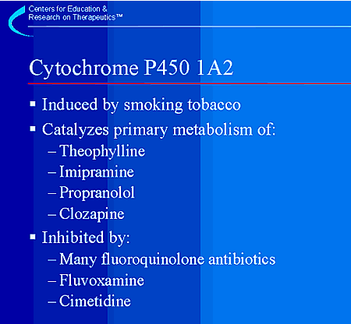
Cytochrome P450 1A2 is an important drug metabolizing enzyme in the liver that metabolizes many commonly used drugs including theophylline, imipramine, propranolol, and clozapine. CYP1A2 is induced in a clinically relevant manner by tobacco smoking. The clearance of theophylline, imipramine, propranolol and clozapine are all increased by smoking. Thus, people who smoke may require higher doses of some of the medications that are substrates of CYP1A2. In contrast, a smoker would require a decrease in theophylline dosage if, for example, smoking were discontinued and the enzyme no longer induced. This topic has been recently reviewed by Zevin and Benowitz.1
Inhibitors of CYP1A2, including some fluoroquinolone antibiotics, can increase the plasma concentrations of drugs that are metabolized by CYP1A2,with a potential for increased toxicity.2,3
1Zevin S, Benowitz NL. Drug interactions with tobacco smoking. An update. Clin Pharmacokinet 1999;36(6):425–438. 2Raaska K, Neuvonen PJ. Ciprofloxacin increases serum clozapine and N-desmethylclozapine: a study in patients with schizophrenia. Eur J Clin Pharmacol 2000;56(8):585–589. 3Grasela TH, Jr., Dreis MW. An evaluation of the quinolone-theophylline interaction using the Food and Drug Administration spontaneous reporting system. Arch Intern Med 1992;152(3):617–621.

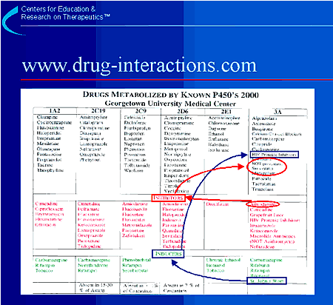
It would be impossible to memorize all of the drug interactions that have been presented here. Fortunately there are aids to help health care providers to anticipate and prevent drug interactions, such as the tool shown here. This is a pocket version of a much larger CYP P450 drug interaction table. A more complete version of this card is maintained on the Internet at www.drug-interactions.com. This table includes a listing of the 6 major cytochrome P450 isozymes involved in drug metabolism and the drugs that are metabolized by them. We recommend using this or another table as a quick reference for detection of potential drug interactions.
If 2 drugs are metabolized by the same cytochrome P450 isozyme, it is very possible that competitive inhibition could lead to higher than usual levels of either or both of the drugs. If a drug is metabolized by a specific cytochrome P450 and is taken with an inhibitor or inducer of that isozyme, an interaction is also likely.
The following are examples of how to use this card. Suppose your patient is taking amiodarone and you want to add a statin agent to decrease the patient’s cholesterol (follow red circles and arrows above). The card shows that amiodarone is an inhibitor of CYP2D6 and CYP3A. We also note that lovastatin and simvastatin are metabolized by CYP3A and that if given with amiodarone (which is inhibiting the enzyme) a toxic level of the statin may occur. The result may be an adverse reaction (rhabdomyolysis or liver toxicity). The best choice would be pravastatin, which is not metabolized by CYP3A. Another example would be if your patient were taking an HIV protease inhibitor and wants to take St. John’s wort (follow green squares and arrows above). According to the card, St. John’s wort induces CYP3A4, which metabolizes most protease inhibitors. The concomitant administration of St. John’s wort with protease inhibitors could result in the induction of CYP3A4, increased metabolism, and subtherapeutic levels of the protease inhibitor.
Laminated versions of this card can be ordered from the website listed above. At the website, it is possible to easily obtain the reference for a given drug by clicking on the drug. The website hyperlinks to PubMed and searches for a list of the relevant publications.

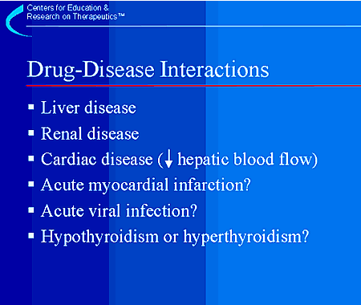
In addition to the drug-drug interactions just reviewed, drug-disease interactions can occur. These include interactions between certain drugs and specific disease states. Severe liver disease can be associated with reduced metabolic clearance and higher plasma levels of drugs extensively metabolized by the liver.1 Although liver disease reduces drug clearance on average, the change is relatively small and usually not clinically relevant except in patients with near terminal liver disease. The effects of renal disease on elimination of drugs that are primarily cleared renally are more predictable, and well-established guidelines exist for dosage of many drugs in renal disease.2 Heart failure reduces liver blood flow and causes a reduction in clearance for drugs such as lidocaine or propranolol that are usually extensively cleared by the liver,3 and acute myocardial infarction reduces clearance of some drugs, such as lidocaine, as well.4 Acute viral infection and changes in thyroid function have been associated with altered clearance for some drugs, such as theophylline and warfarin.5–7 However, the results are so variable between individuals that it is difficult to predict who is at risk, and these changes are usually only clinically important in cases of extremely impaired organ function.
1Brouwer KLR, Dukes GE, Powell JR. Influence of liver function on drug disposition. In: Evans WE, Schentag JJ, Jusko WJ, editors. Applied Pharmacokinetics: Principles of Therapeutic Drug Monitoring. Vancouver, WA: Applied Therapeutics, Inc.; 1992:6-1-6-59. 2Lam YW, Banerji S, Hatfield C, Talbert RL. Principles of drug administration in renal insufficiency. Clin Pharmacokinet 1997;32(1):30-57. 3Shammas FV, Dickstein K. Clinical pharmacokinetics in heart failure. An updated review. Clin Pharmacokinet 1988;15(2):94-113. 4Pieper JA, Johnson KE. Lidocaine. In: Evans WE, Schentag JJ, Jusko WJ, editors. Applied Pharmacokinetics:Principles of Therapeutic Drug Monitoring. Vancouver, WA: Applied Therapeutics Inc.; 1992:21-1-21-37. 5Pokrajac M, Simic D,Varagic VM. Pharmacokinetics of theophylline in hyperthyroid and hypothyroid patients with chronic obstructive pulmonary disease. Eur J Clin Pharmacol 1987;33(5):483–486. 6Stephens MA, Self TH, Lancaster D, Nash T. Hypothyroidism: effect on warfarin anticoagulation. South Med J 1989;82(12):1585–1586. 7Yamaguchi A, Tateishi T, Okano Y, Matuda T, Akimoto Y, Miyoshi T, et al. Higher incidence of elevated body temperature or increased C-reactive protein level in asthmatic children showing transient reduction of theophylline metabolism. J Clin Pharmacol 2000;40(3):284–289.

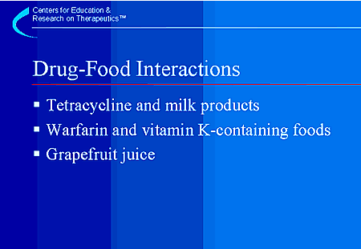
Several drugs are known to interact with foods,1 some of which are listed here. One of the early observations was the reduced absorption of tetracycline when taken with milk products. The chelation of tetracycline by calcium prevents it from being absorbed from the intestines. Dietary sources of vitamin K, such as spinach or broccoli, may increase the dosage requirement for warfarin by a pharmacodynamic antagonism of its effect. Patients should be counseled to maintain a consistent diet during warfarin therapy. Grapefruit juice contains a bioflavonoid that inhibits CYP3A and blocks the metabolism of many drugs. This was first described for felodipine (Plendil)2 but has now been observed with several drugs.3 This interaction can lead to reduced clearance and higher blood levels when the drugs are taken simultaneously with grapefruit juice. With regular consumption, grapefruit juice also reduces the expression of CYP3A in the GI tract.4
1Williams L, Davis JA, Lowenthal DT. The influence of food on the absorption and metabolism of drugs. Med Clin N Am 1993;77(4):815–829. 2Bailey DG, Spence JD, Munoz C, Arnold JM. Interaction of citrus juices with felodipine and nifedipine. Lancet 1991;337(8736):268–269. 3Kane GC, Lipsky JJ. Drug-grapefruit juice interactions. Mayo Clin Proc 2000;75(9):933–942. 4Lown KS, Bailey DG, Fontana RJ, Janardan SK, Adair CH, Fortlage LA et al. Grapefruit juice increases felodipine oral availability in humans by decreasing intestinal CYP3A protein expression. J Clin Invest 1997;99(10):2545–2553.

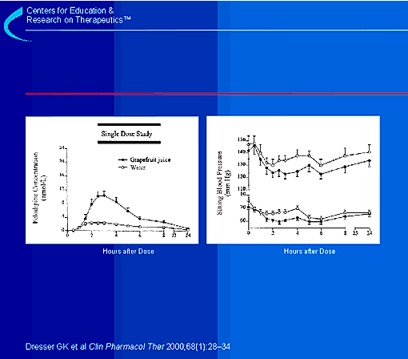
This slide demonstrates the effects of grapefruit juice on felodipine pharmacokinetics and pharma-codynamics.1 The left graph shows felodipine plasma concentrations at specific time points, up to 24 hours, following administration of a single dose of felodipine with 250 cc of grapefruit juice or water. The right graph shows systolic and diastolic blood pressure from the same time points. Compared with water, there is an increase in felodipine plasma concentrations, as well as a decrease in systolic and diastolic blood pressure. This demonstrates a potentially clinically significant effect of the grapefruit juice-felodipine interaction.
1Dresser GK, Bailey DG, Carruthers SG. Grapefruit juice-felodipine interaction in the elderly. Clin Pharmacol Ther 2000;68:28–34.

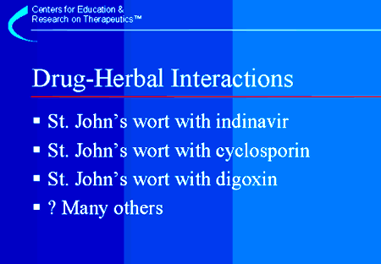
It has been suspected that herbal remedies could interact with other herbals or even prescription drugs. Ingestion of St. John’s wort has resulted in several clinically significant interactions with drugs that are metabolized by CYP1A2 or CYP3A, including indinavir (Crixivan)1 and cyclosporin (Sandimmune and Neoral).2,3 An interaction with digoxin (Lanoxin) has also been reported that may be mediated by interference with P-glycoprotein (P-GP), a transport system that pumps drugs across membranes.4 These interactions are most likely due to induction of the cytochrome P450 isozyme or the drug transporter and have caused decreased plasma concentrations of prescription drugs. In the case of cyclosporin, subtherapeutic levels resulted in transplant organ rejection. Warnings about St. John’s wort drug interactions have been extended to oral contraceptives, with labeling suggesting the possibility of breakthrough bleeding and potential for loss of contraceptive effect.
It is likely that many drug-herbal interactions exist but have not yet been detected. It is therefore important that health care providers obtain a complete drug history that includes herbal remedies and other natural products and dietary supplements and that they be alert to potential interactions.
1Piscitelli SC, Burstein AH, Chaitt D, Alfaro RM, Falloon J. Indinavir concentrations and St John’s wort. Lancet 2000;355(9203):547–548. 2Breidenbach T, Hoffmann MW, Becker T, Schlitt H, Klempnauer J. Drug interaction of St John’s wort with cyclosporin. Lancet 2000;355(9218):1912. 3Ruschitzka F, Meier PJ, Turina M, Luscher TF, Noll G. Acute heart transplant rejection due to Saint John’s wort. Lancet 2000;355(9203):548–549. 4Johne A, Brockmoller J, Bauer S, Maurer A, Langheinrich M, Roots I. Pharmacokinetic interaction of digoxin with an herbal extract from St John’s wort (Hypericum perforatum). Clin Pharmacol Ther 1999; 66(4):338–345.

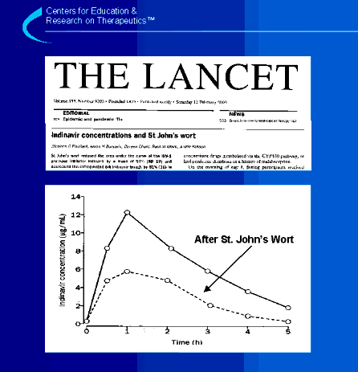
This slide shows the mean plasma concentration time course of indinavir in 8 healthy volunteers with indinavir alone or after taking indinavir with St. John’s wort.1 After administration of St. John’s wort, a 57% reduction was observed in the indinavir area under the plasma concentration-time curve (AUC), indicative of reduced exposure to indinavir. This study prompted a public health advisory released by the FDA on February10, 2000 (www.fda.gov/cder/drug/advisory/stjwort.htm) about the risk of drug interactions between St. John’s wort and other medications. The potential for loss of therapeutic efficacy due to this interaction suggests the importance of taking a complete medication history. This history should include questions about herbal therapy and other natural products as well as over-the-counter medications.
1Piscitelli SC, Burstein AH, Chaitt D, Alfaro RM, Falloon J. Indinavir concentrations and St John’s wort. Lancet 2000;355(9203):547–548.

ADR Reporting
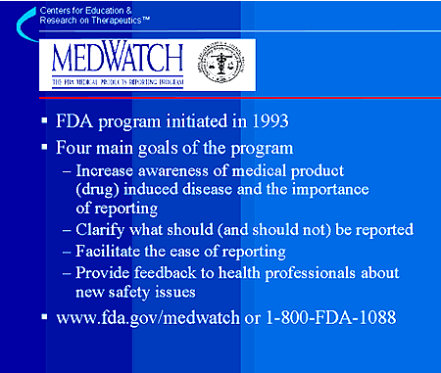
Given the vital importance of postmarketing surveillance of new drugs, MedWatch, the FDA Medical Products Reporting Program, was established in 1993. The program has 4 general goals. The first goal is to increase awareness of drug, device and other medical product induced disease and the importance of reporting.
The second goal of MedWatch is to clarify what should (and should not) be reported. Health professionals are asked to limit reporting to serious adverse reactions. This is important both in improving the quality of individual reports and enabling the FDA and the manufacturer to focus on the most significant reactions. Causality is not a prerequisite for reporting; suspicion that a medical product may be related to a serious reaction is sufficient reason to report.
The third goal is to make it as easy as possible to report to the FDA. Only one reporting form is necessary. The postage-paid form for voluntary reporting is available in the back of the Physicians’ Desk Reference or from the FDA via the toll free number (1-800-FDA-1088) or from the FDA/MedWatch website (www.fda.gov/medwatch).
The fourth and final goal of the program is to provide feedback to health professionals about new safety problems with pharmaceuticals and medical devices. Safety-related labeling changes, "Dear Health Care Professional" correspondence, safety alerts and FDA public health advisories are posted on the FDA/MedWatch website.
1Kessler DA. Introducing MedWatch: a new approach to reporting medication and device adverse effects and product problems. JAMA 1993;269:2765–8.

Preventing Drug Interactions
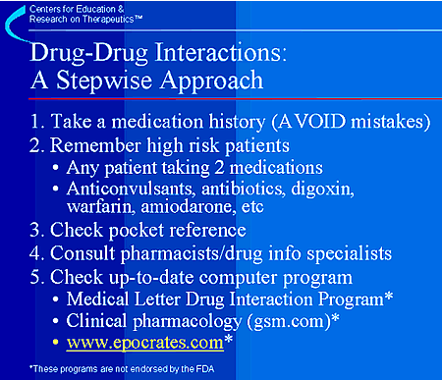
In closing, it is impossible to remember all of the drug interactions that can occur. It is therefore important to develop a stepwise approach to preventing adverse reactions due to drug interactions.
First, taking a good medication history is essential. The "AVOID Mistakes" mnemonic presented on the next slide can help health care practitioners to develop good habits when performing this task.
Second, it is essential that physicians develop an understanding of which patients are at risk for drug interactions. Of course any patient taking 2 medications is at some risk. Studies show that the rate of adverse drug reactions increases exponentially in patients taking 4 or more medications.1 Importantly, some categories of drugs are especially at high risk for interactions. These categories include anticonvulsants, antibiotics, and certain cardiac drugs such as digoxin, warfarin, and amiodarone.
Third, any time a patient is taking multiple drugs, we recommend that the first step be to check a readily available pocket reference, recognizing that the interaction may not be listed and a more complete search may be required.
Fourth, consult other members of the health care team. Depending upon the practice setting, this may be a clinical pharmacologist, a hospital pharmacist, a specially trained office staff nurse, or the nearby pharmacist in community practice.
Fifth, use one of the computerized databases available. Up-to-date databases are maintained by gsm.com and epocrates.com, and others.* The latter can be placed on a hand-held computer (e.g. Palm Pilot) and can be configured to automatically update each time you synchronize with the desktop computer. The Medical Letter Drug Interaction Program is inexpensive and updated quarterly.*
*These programs are not endorsed by the FDA.
1Jacubeit T, Drisch D, Weber E. Risk factors as reflected by an intensive drug monitoring system. Agents Actions 1990;29:117–125.

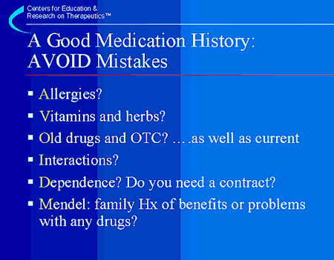
Finally, use of the "AVOID Mistakes" mnemonic can help to develop good practice habits and offers a useful way of remembering the components of a good drug history.
A history of allergies or previous history of adverse reactions to any drugs should be elicited in a way that will yield the most useful information. For example, rather than asking about a history of drug allergy, the patient should be asked whether there is any drug that should not be prescribed for any reason. A specific question should be asked about the use of vitamins and herbal or other natural products. Old drugs (prescription and over the counter) should be considered as well as new drugs, since some of the effects (either toxicity or potential for drug interactions) could be relatively long-lasting. The potential for adverse drug interactions should be evaluated. The need for a behavioral contract between the physician and the patient should be considered in an effort to help the patient reach the therapeutic goal, either in the case of drug dependence or adherence to a therapeutic regimen, with a clear plan. Finally, a family history of benefits or problems with any medications will help determine whether pharmacogenetics should be considered in tailoring drug therapy.

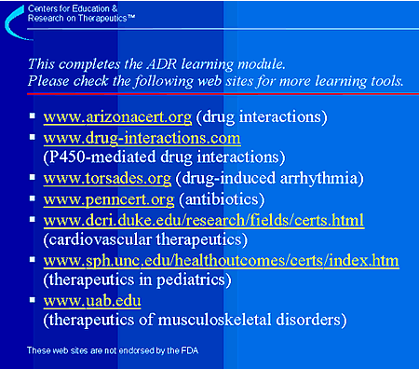
These web sites are not endorsed by the FDA.

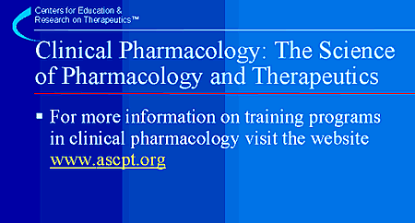
Post-doctoral training for physicians and pharmacologists interested in clinical pharmacology as a career is available at NIH-sponsored sites as well as other sites throughout the country. For a list of available training programs and contact information, see the website of the American Society for Clinical Pharmacology and Therapeutics (ASCPT).

